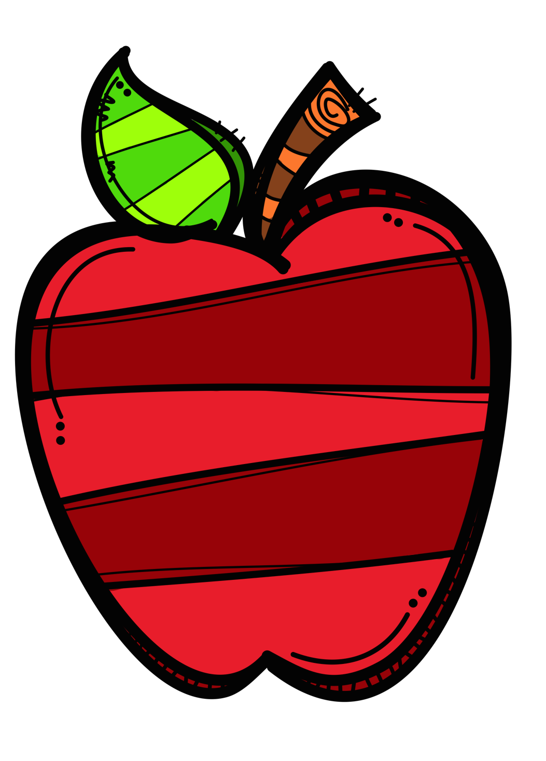

**Welcome to a New School Year!**

**I am Mrs. Francis**



**About Me**

I have 3 boys 15, 13 and 12 who play bridge and piano. My middle child will begin cross country running this year. I am very proud of them! In my free time I enjoy doing some of my favorite things like exercising, reading and listening to music.

**My Teaching Philosophy**

I realize teaching your child is a privilege as well as an awesome responsibility that I take very seriously. I will always encourage your child. We are partners, you and I, along with your child, in this quest. I invite all questions/concerns you may have.

I expect parents who are highly involved in both in/out school activities.

No one can do it alone. It has to be a team effort. I expect us all to rise to that challenge and exceed it.

**My Education**

I went to New Jersey City University where I obtained a BA in Political Science and a Master’s in Early Childhood Education. I also have a Master’s in Curriculum and Instruction from Nova Southeastern University.

I am so excited to embark on a new year! We will have so much fun learning this year!

**Contact Information**

My door is always open. If you have something to share, please don’t hesitate to email or dojo me. My Email: [francila@orange.k12.nj.us](mailto:francila@orange.k12.nj.us)

**\*\*Please send me your email address so I can add you to ClassDojo.**

**It is the primary method of communication.**

**Supply list is attached**

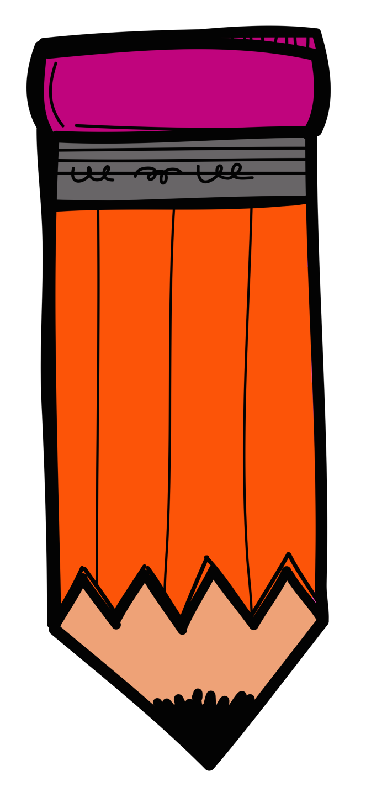**Please send all supplies on the first day of School**

**Supply List**

**\*\*NO supplies will be shared this year**

**6 composition books (wide-ruled only)**

**Large size pencil case/supply box (to hold glue, pencils, markers)**

**2 boxes of pencils (pre-sharpened)**

**2 boxes of colored pencils**

**1 durable leak-proof water bottle(labeled with name)**

**2 Pack of Crayons *24 Count**

**2 Glue Sticks**

**A pack of construction paper**

**4 colored folders**

**1 black sharpie (fine point)**

**Pencil sharpener**

**2-3 packs of post its**

**4 Boxes of Tissues**

**2 Containers of Clorox Wipes**

**3 Reams of Copy Paper**

**2 packs of dry-erase markers**

**-1 personal headphones (over the ear)**

**2 boxes of zip loc baggies (1 quart and 1 gallon)**

Please write your child’s name on all items. It is important for each child to send in all requested supplies, so your child has the necessary tools needed for learning in our classroom.

**NO ITEMS WILL BE SHARED WITH OTHER STUDENTS**. **Please make sure your child’s name is on ALL supplies. Thank you!**

Here are a few ideas to help your child get ready for the school year

1. Ask your child to think about something from this summer to share.
2. Talk with your child about some learning goals and hopes for this year. What do you want to learn?
3. Please help your child get back on a school schedule so they will be well rested. Also practice wearing a mask if they are not used to it.